**Skewness and Kurtosis:**

|  |  |  |  |  |  |  |  |
| --- | --- | --- | --- | --- | --- | --- | --- |
|  | **sl_no** | **ssc_p** | **hsc_p** | **degree_p** | **etest_p** | **mba_p** | **salary** |
| Kurtosis | -1.2 | -0.60751 | 0.0 | 0.052143 | -1.08858 | -0.470723 | -0.239837 |
| skew | 0.0 | -0.132649 | 0.0 | 0.244917 | 0.282308 | 0.313576 | 0.8067 |

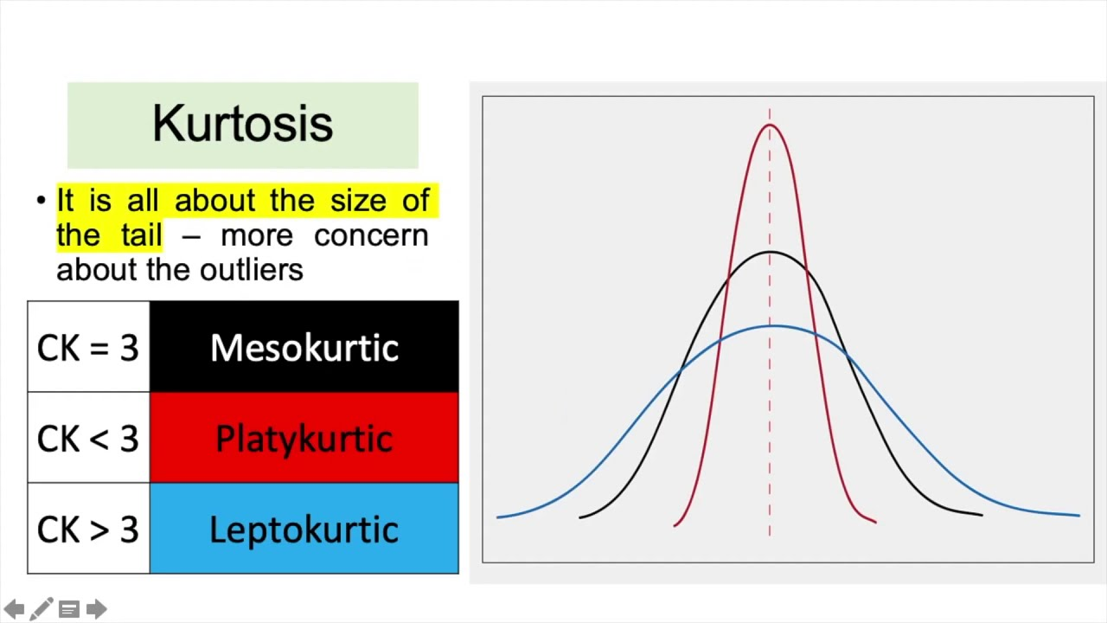

The **Kurtosis** for 10th standard pass mark is **-0.60751 (platy Kurtosis)**

The **Kurtosis** for 12th standard pass mark is **0.0 (platy Kurtosis)**

The **Kurtosis** for degree students pass mark is **0.052143 (platy Kurtosis)**

The **Kurtosis** for entrance exam mark is -**1.08858 (platy Kurtosis)**

The **Kurtosis** for MBA studentsmark is -**0.470723 (platy Kurtosis)**

The **Kurtosis** for Salary is -**0.239837 (platy Kurtosis)**

**Skewness**

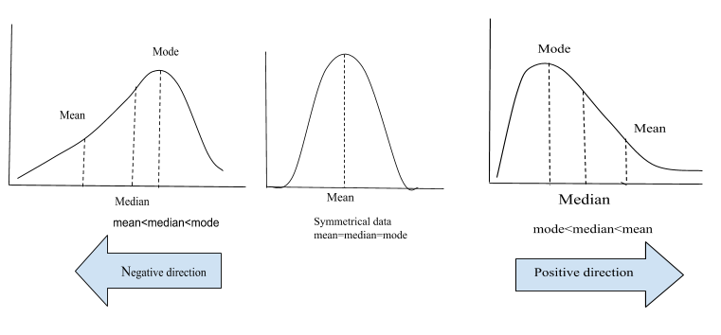

The **Skewness** for 10th standard pass mark is -0.60751 (Mean is high)

The **Skewness** for 12th standard pass mark is 0.0 (normal)

The **Skewness** for Degree standard pass mark is 0.244917 (Normal)

The **Skewness** for Entrance standard pass mark is 0.282308 (Normal

The **Skewness** for MBA pass mark is 0.313576 (Normal)

The **Skewness** for Salary is 0.8067 (Normal)